HIGH ENERGY
Roles:
Daniel – coordinator
Anahy – P.E. inventor
Rica – journalist / secretary
Justerine – speaker
Ona – computer technician

- We are going to put music. We have made a mix of songs, to motivate the class.

- Every member of the group will participate in the explanation.

- Anahy, Rica and Ona will do the demonstration of the exercises.

- The routines will be in partners.

- Time: 40 seconds each exercise and 10 seconds of break time. The students will do the activity two times.

- Materials: 15 mats, 4 elastic bands, 3 tennis balls and a fitball.

Justerine will watch if the students are doing okay the exercises

Anahy will play the music and take the time and, also, she will say if we need to change the activity.

Daniel will watch if the students are doing okay the exercises.

Ona will watch if the students are doing okay the exercises.

Rica will record the circuits will watch if the students are doing okay the exercises.

- Arm exercises: the most important muscles in this exercises are triceps and biceps.
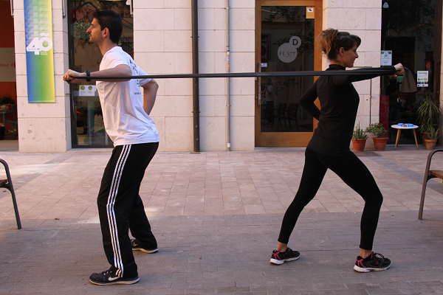

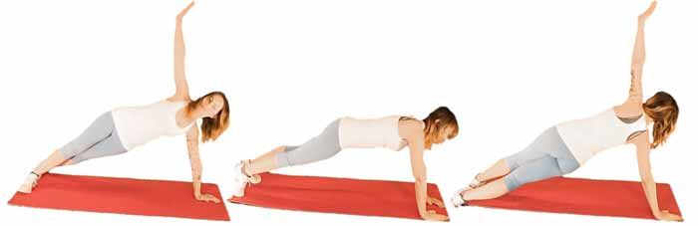

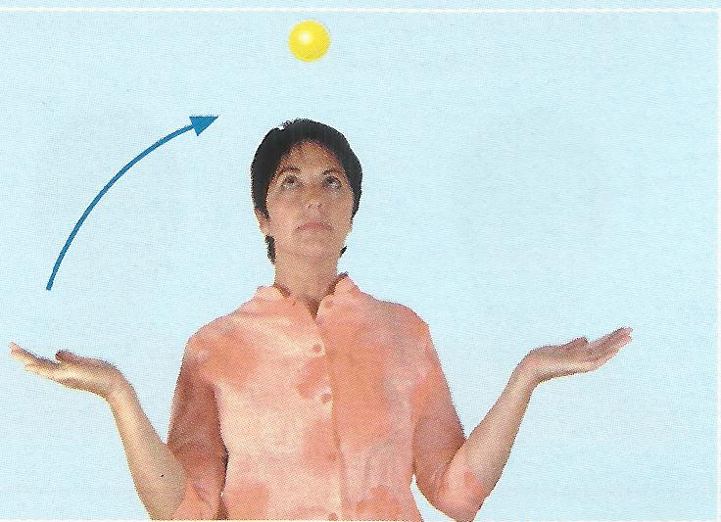
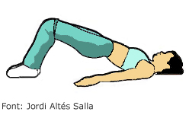
- Gluteus exercises: gluteal muscles are the important muscle in this excercise. It consist gluteus minimums, mediums and maximus.
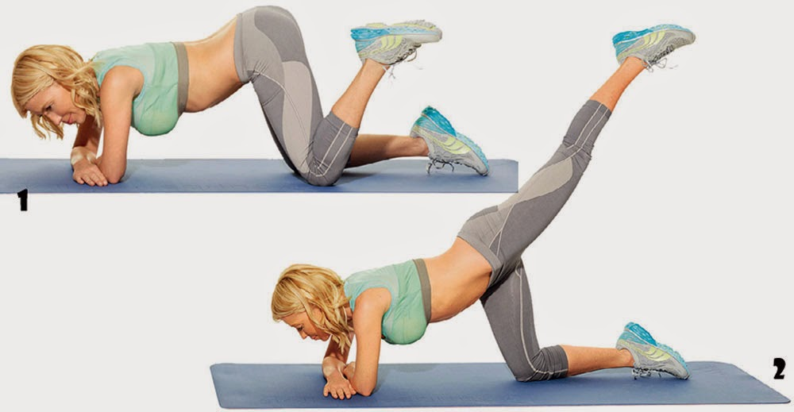

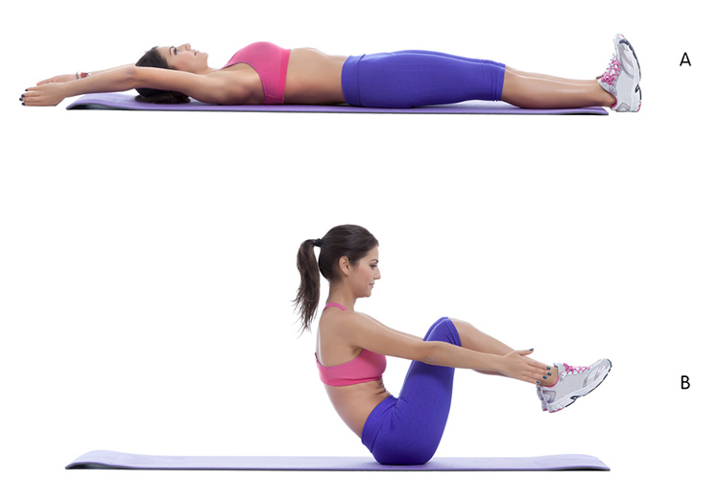
- Abs exercises: in this exercises we use our abdominal. Base on my research, it can keep your torso in a more stable position whenever you move or playing sport. And it can’t prevent and control lowerback pain.

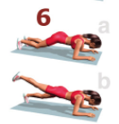

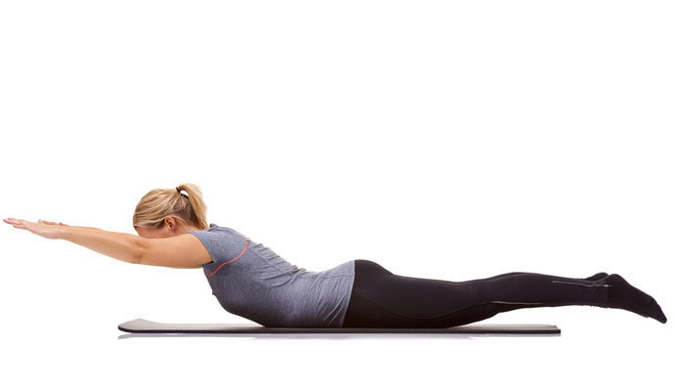
- Shoulder exercise: the important muscle is rotator cuff as well as deltoid muscle. Stabilize the shoulder joint, helping you avoid injuries.

- Legs exercises: the important muscle is quadriceps refers to a group of four muscles on the front of the thigh that are responsible for straightening your knee.
